Data Models

types:
conceptual DBM - high level business needs
logical DBM - joins , relationships etc...
physical DBM - real physical table , pk , constraints
---------------------------------------------------------------------
Dimensional Data Model
Store data in form of facts and dimensions tables

Fact table
Store only facts –
Facts = numeric columns , keys (fk)
- In one data model we have one fact table and multiple dimensions table around it
Dimension table
Numeric columns cant goes to Dimension table
-it only holds context of table
EX:
Dimdate
Fact table
DimRigon
Dimproduct
Dimcustmor

Dimensional modelling

Star schema
-there is no hierarchy
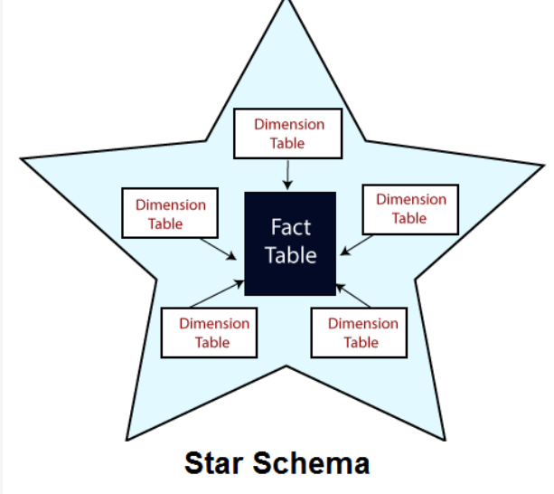
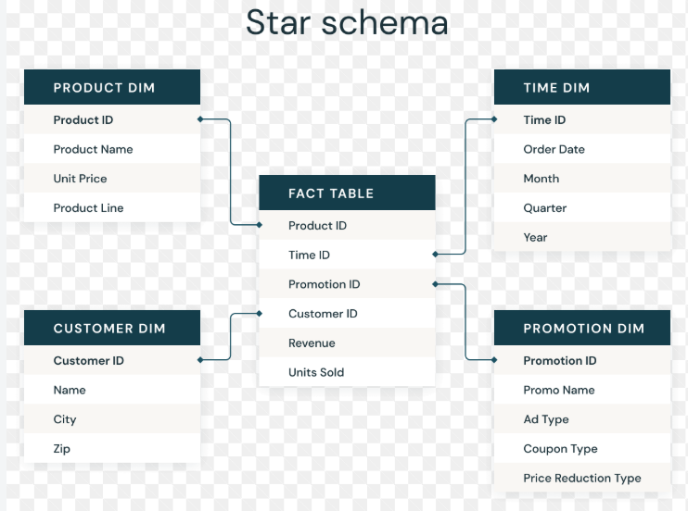

Snow flake schema
-it have hierarchy

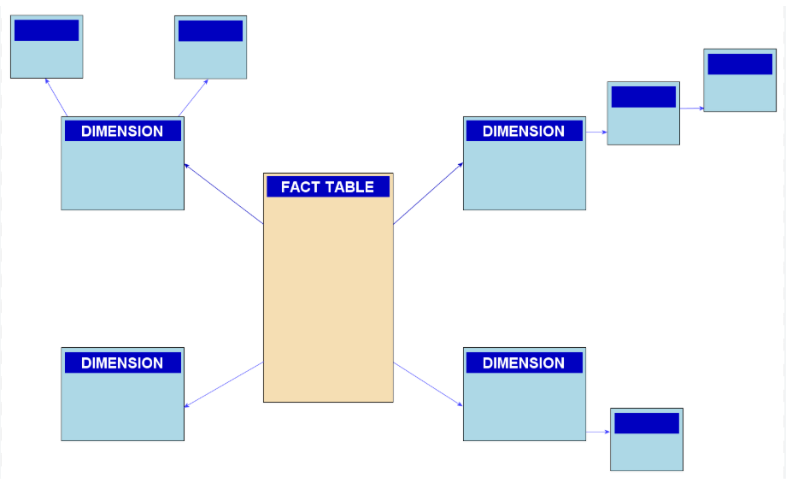
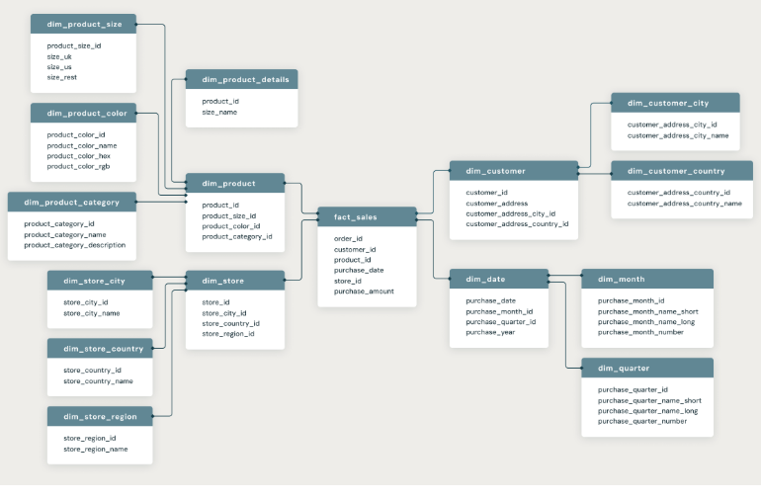

Types of Fact Tables
- granular/Transitional fact table
1 translation = 1 row
- Periodic fact table / snapshot fact table
1 transaction != 1 row
Here 1 Row = many transaction OR monthly transaction
- Accumulating Fact table
1 row = Process
EX: Accumulating Fact table
Amazon delivery dates like,
21june order pack
23 june order despatch
24june order delivered

- Conformed Dimensions
1 dimensions table connect with multiple fact table
- Role playing Dimensions
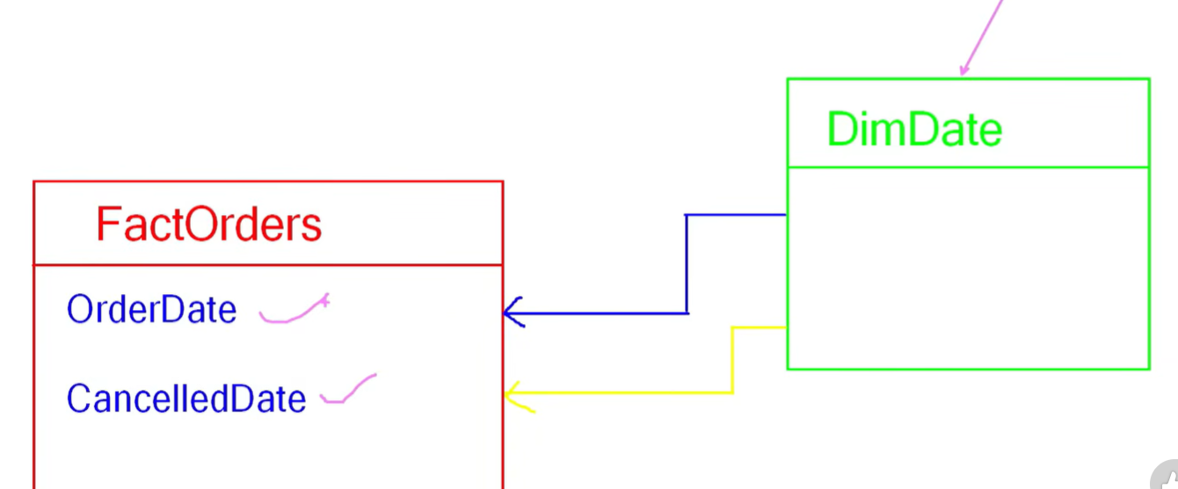
Two different date and role
- junk Dimensions
- Degenerate Dimensions

Dimensions:
Type – 0
Type – 1
Type – 2
Type – 3

Type-0
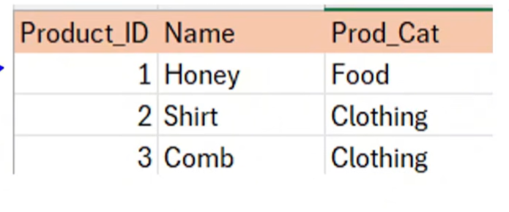
Type-1
Upsert
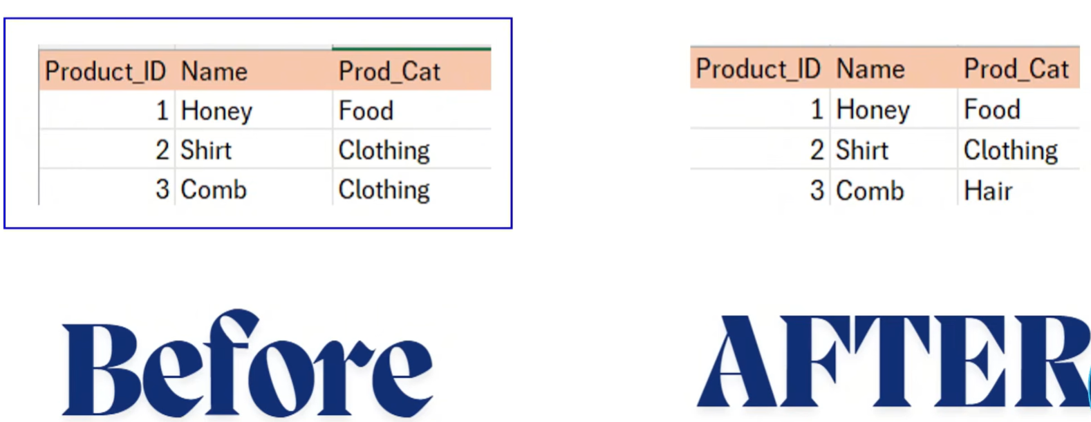
Type -2
History
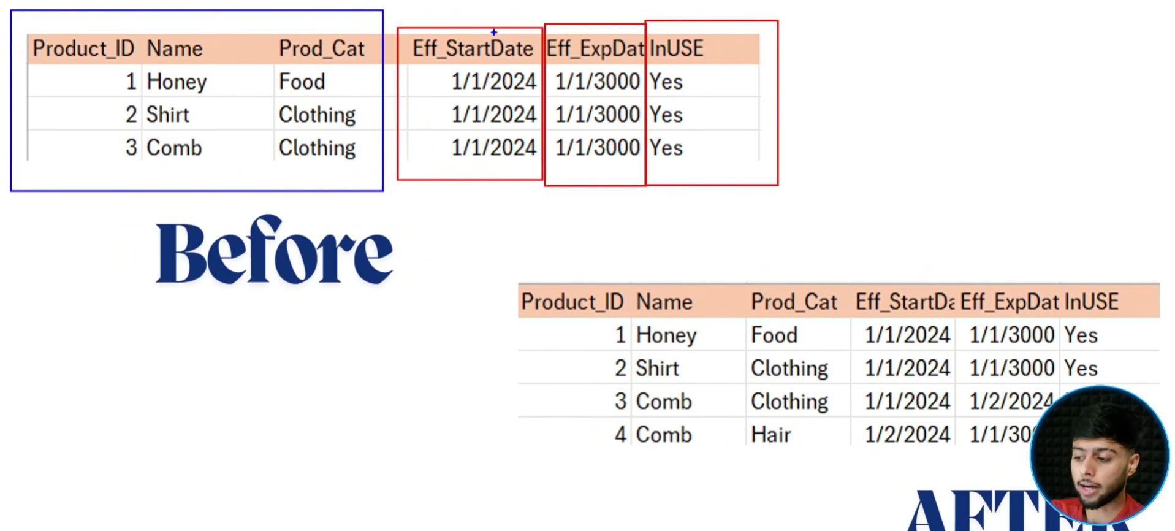

Type -3
Prev Vlaue

